# 1. Overview Zigbee Network

General Zigbee topology

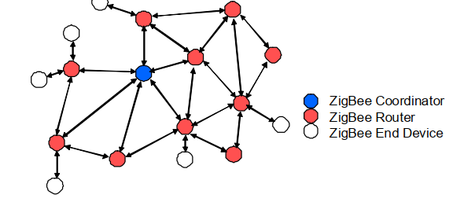

Coordinator:

* Starts a non-beaconed PAN
* Allow other device to joint it.
* Buffer messages for sleeping End.
* Provide binding and address-table services.
* Routes messages
* Dynamically repairs routing
* Can have I/O capability
* Manage security
* Radio always on.

Router

* Does not own or start PAN (Scans to find a network to join)
* Allow other devices to join it after PAN has been started
* Routes messages
* Dynamically repairs routing
* Buffers messages for sleeping End Devices
* Support secure messaging
* Can have I/O capability
* Radio always on

End Device

* Scans to find a PAN to join
* Polls parent to get messages( can be disabled)
* Can be mobile
* Radio/CPU can sleep.

The Coordinator establish PAN

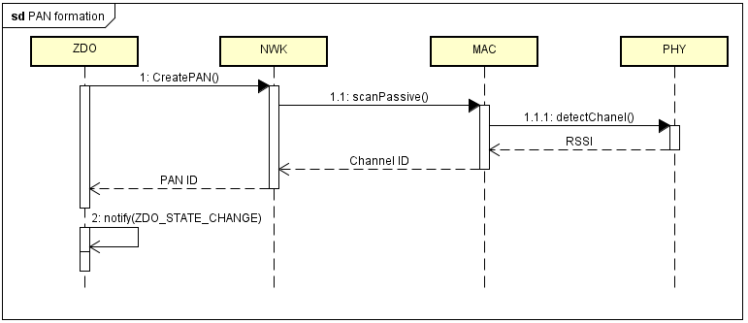

* When starting up, the ZDO layer request forming PAN ID
* NWK call to MAC layer to perform passive scan
* MAC call to lower layer which is Physical layer to detect energy for each channel.
* The NWK continuous performing active scan by requesting beacon to open channel
* Finally , the NWK will raise event to notify changed status up ZDO layer.

PAN discovery/join process

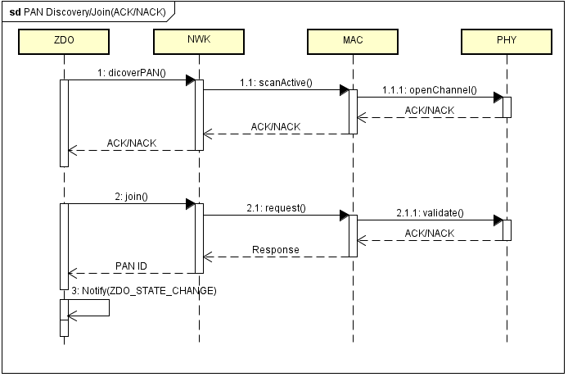

* From the ZDO layer to call ZWK layer to discover PAN
* ZWK will perform active scan by calling MAC layer
* When the confirmed discovery process, It will raise to ZDO layer
* Every chip has a unique 64-bit IEEE address (used for joining ID)
* ZDO determines which PAN to join by PAN ID.

## Address Allocation

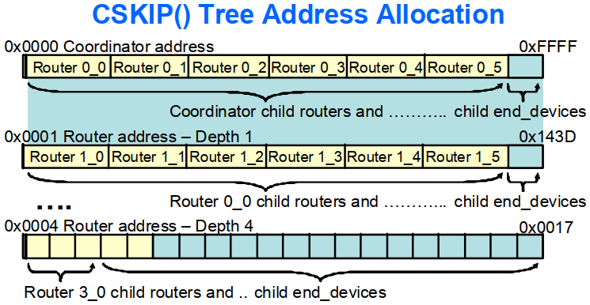

## Routing

Every routing device contains a Routing Table (Destination address, Next hope node, Link status)

* ROUTE_EXPIRY_TIME: Routes can automatically expire if not used for
* MAX_RREQ_ENTRIES: sets the maximum number of simultaneous route discoveries can be performed.

Automatic Rerouting

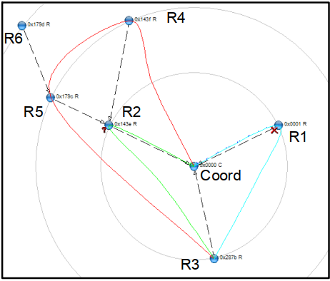

Coordinator sends msgs to R3 via R1 (blue path), then R1 fails

Coordinator sends msgs to R3 via R2(green path), then R2 fails

Coordinator send msgs to R3 via R4 and R5 (red path)

Configuring PAN ID in f8wConfig.cfg

* If PAN_ID = 0xFFFF and device = Coordinator: Device uses IEEE address to choose a PAN_ID (last 2 byte)
* If PAN_ID = 0xFFFF and device = Router or EndDevice: Device will join any available PAN
* If PAN_ID ? 0xFFFF and device= Coordinator: Device will use the set value for the PAN_ID
* If PAN_ID? 0xFFFF and device = Router or End Device: Device will only join a PAN that has this PAN_ID.

# Establish Environment

* Download and install IAR

# Hardware component

**- RF/Layout**

+ 2.4 GHz IEEE 802.15.4 Compliant RF Transceivers

+ Programmable Output Power Up to 4.5 dBm

-**Low Power**

+ Active-Mode RX(CPU Idle): 24 mA

+ Active Mode TX at 1dBm (CPU Idle): 29mA

- **Microcontrolle**r

+ High-performance and low-power 8051 micro-controller core with code prefetch

+ 256 KB In-System Programmable Flash

+ 8 KB RAM with retention in All Power Modes

-**Peripherals**

+ Powerful Five channel DMA

+ IEEE 802.15.4 MAC Timer, General-Purpose Timers( One 16 Bits, Two 8 Bits)

+ 32 kHZ Sleep Timer with capture

+ 12 Bit ADC with Eight channels and configurable resolution.

+ 2 UART, 1 SPI

+ Watch dog timers.

**Key features**

Frequency: 2.4 GHz

Communication: SPI and UART

Transceiver: 150m

Power: 2 VDC – 3.6 VDC

Aten: PCB Antena and IPEX

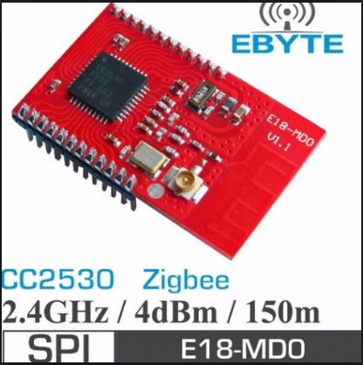

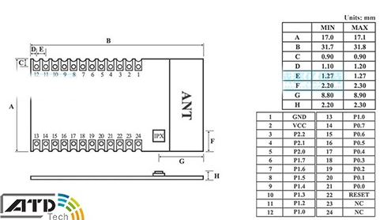

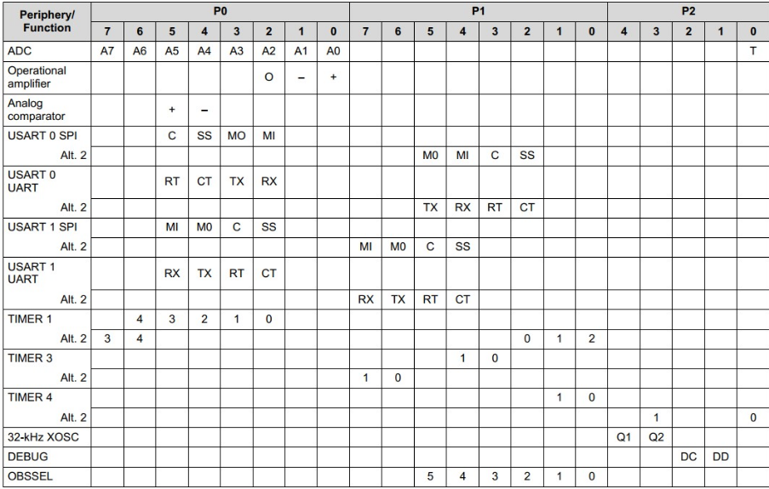

|  |  |  |  |  |  |  |
| --- | --- | --- | --- | --- | --- | --- |
| Function | USB2UART | |  | Function | CC2530 | |
| UART-RX | White |  |  | UART-RXD | Port 0.2 |  |
| UART-TX | Green |  | UART-TXD | Port 0.3 |  |
| Supply | Red |  | Supply |  |  |
| Ground | Black |  | Ground |  |  |
| Function | **LED switch** | |  | Function | **CC Debug** | |
| GPIO | CFG0 | 1.2 |  | Clock | DC |  |
| GPIO | CFG1 | 2.0 |  | Data | DD |  |

## Software component

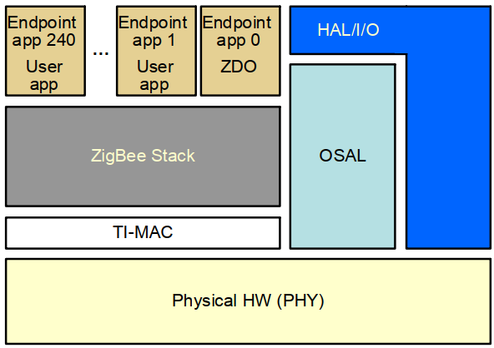

OSAL – operating System Abstract Layer: Initialize the other components

HAL layer: responsible for Initializing hardware component such as UART, GPIO, SPI, Timers, Watchdog

TI-MAC layer: provide and validate MAC address

ZigBee Stack: contain NWK, Service, Security component.

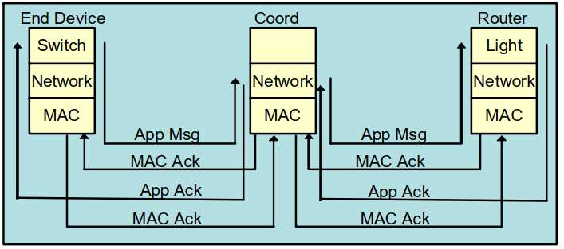

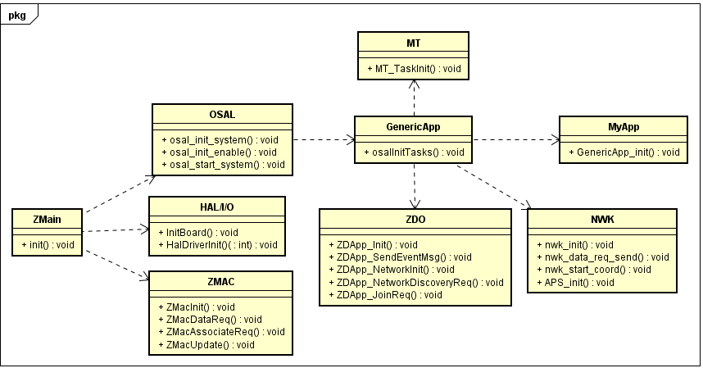

# Project

**Cluster**: Values sent or receive3d over the network are called Cluster (data types)

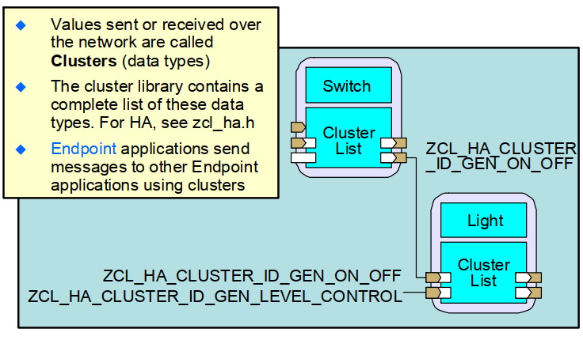

- Endpoint application send message to other Endpoint application using clusters.

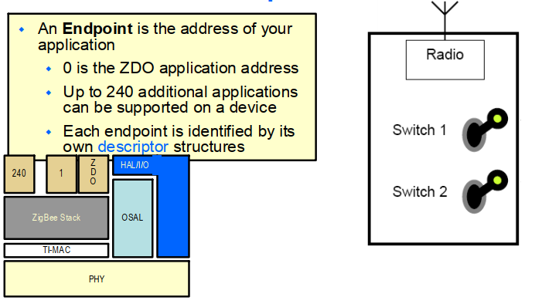

Application Framework and Send/Receive Data

* The AF provides application with structures and function to

+) Manage endpoints

+) Send and receive data ( Address structure, send data function, receive data structure, receive data callback)

Address mode

|  |  |
| --- | --- |
| Addr16Bit | Unicast |
| AddrNotPresent | Indirect – destination address found in binding table |
| AddrBroadcast | Broadcast o all devices, non-sleeping devices or routers/coordinator only |
| AddrGroup | Device can assign themselves to groups addressable here |

**Deployment diagram**

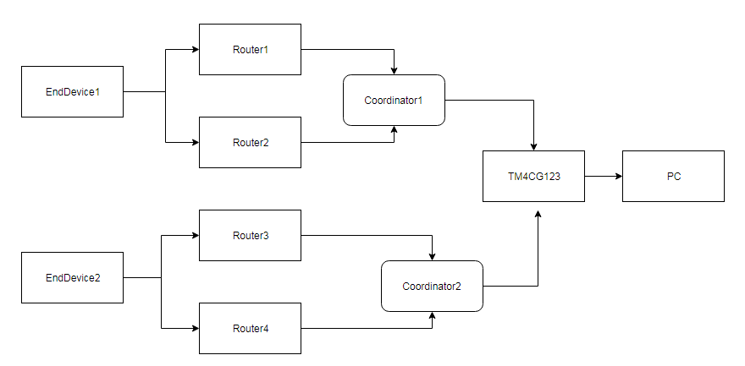

# Project structure

1. Application

Cluster: contain format message

GenericApp: the general application

PowerMeter: measure power of device then send it to coordinator

SmartDevice: collect data from sensor, send to hub center.

2.